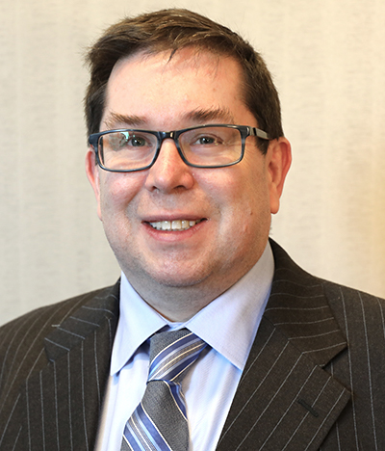

Darryl Hicks is Vice President of Communications for the National Reverse Mortgage Lenders Association. In this capacity, Hicks writes for NRMLA's publications, manages the association's web sites and social media accounts, assists committees and the Board of Directors, and manages the Certified Reverse Mortgage Professional designation. Prior to joining NRMLA in 1999, Hicks spent three years in the Washington, D.C. bureau for National Mortgage News.

